**Aim: Classification using orange tool.**

Step1:- We will be taking the available data files in order to predict the future things so open a new data file and drag the file just over it.

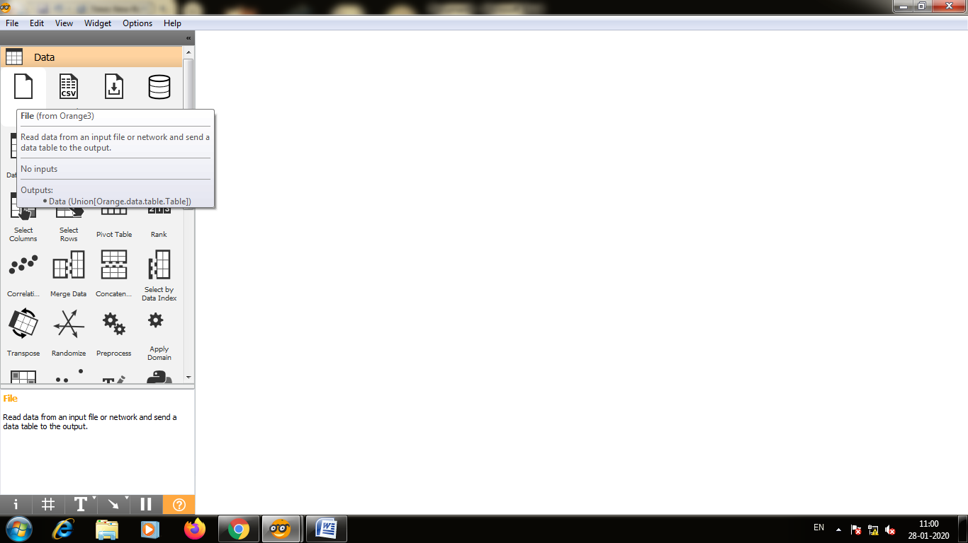

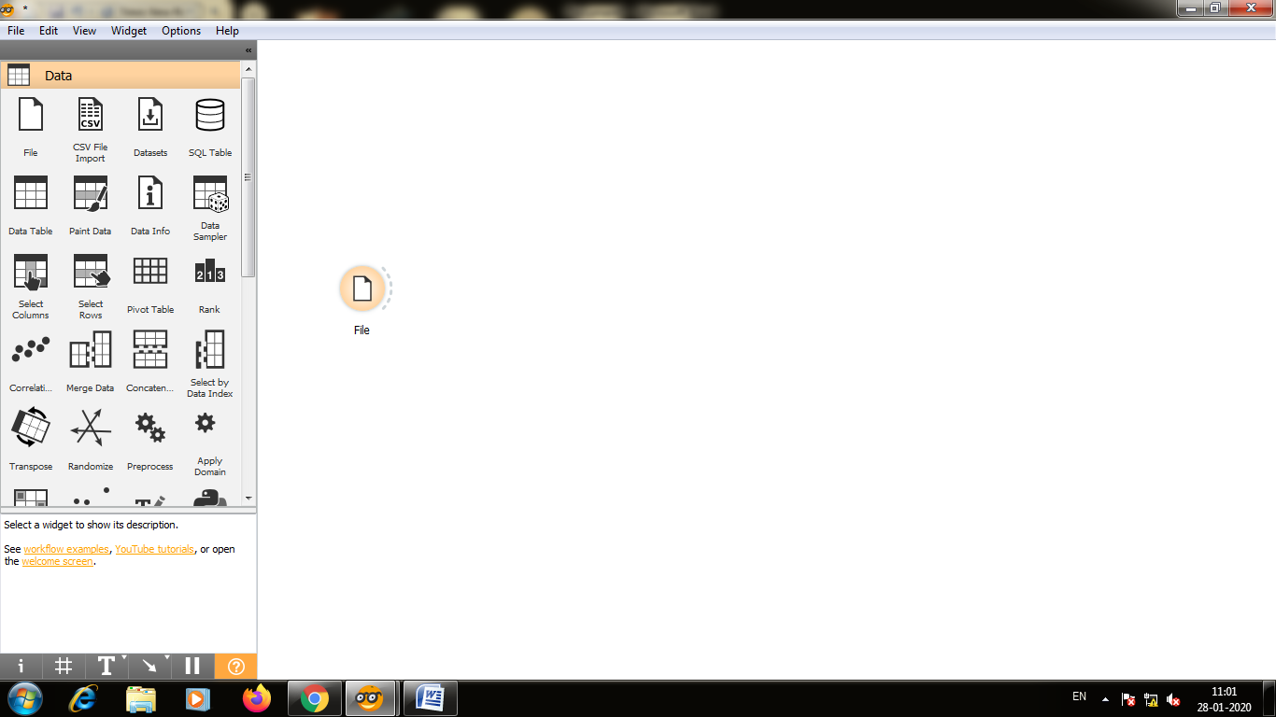

Step2:-Double click on the data file,from the dropdown list select the zoo.tab data file and close it.

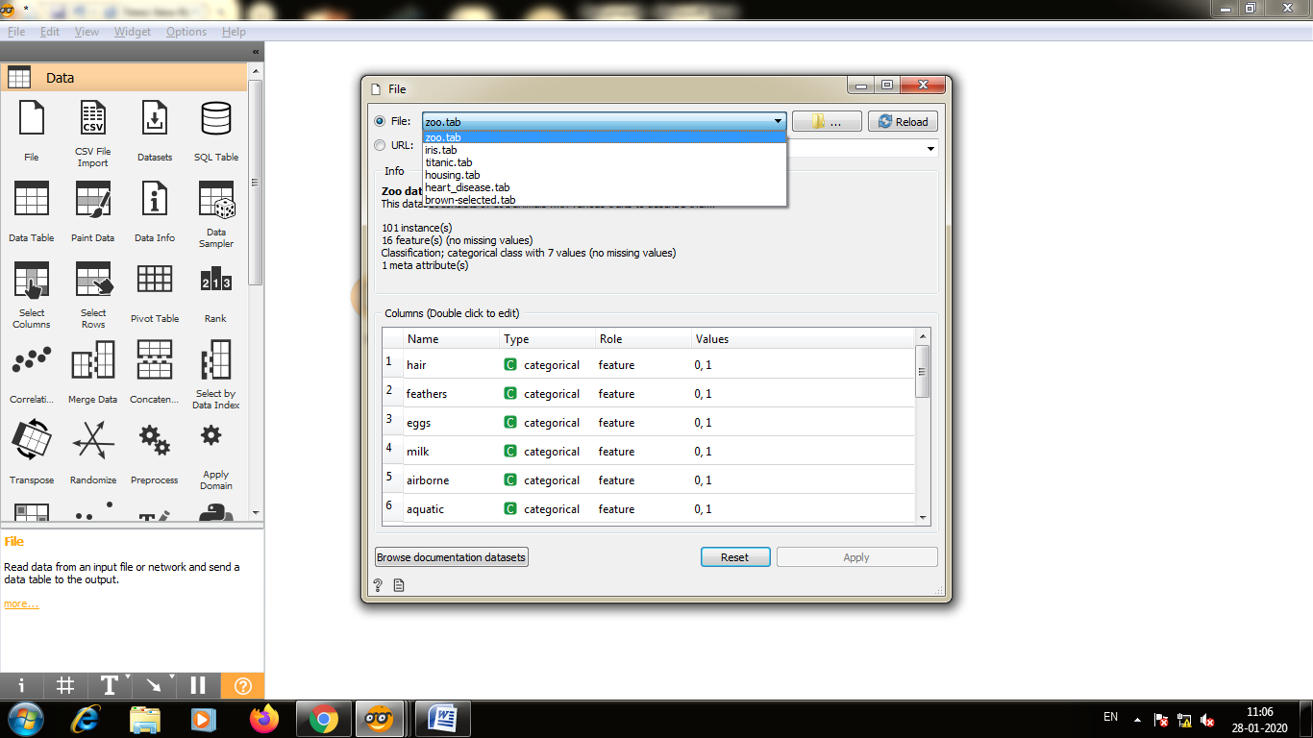

Step3:-Select the file and type data sampler.

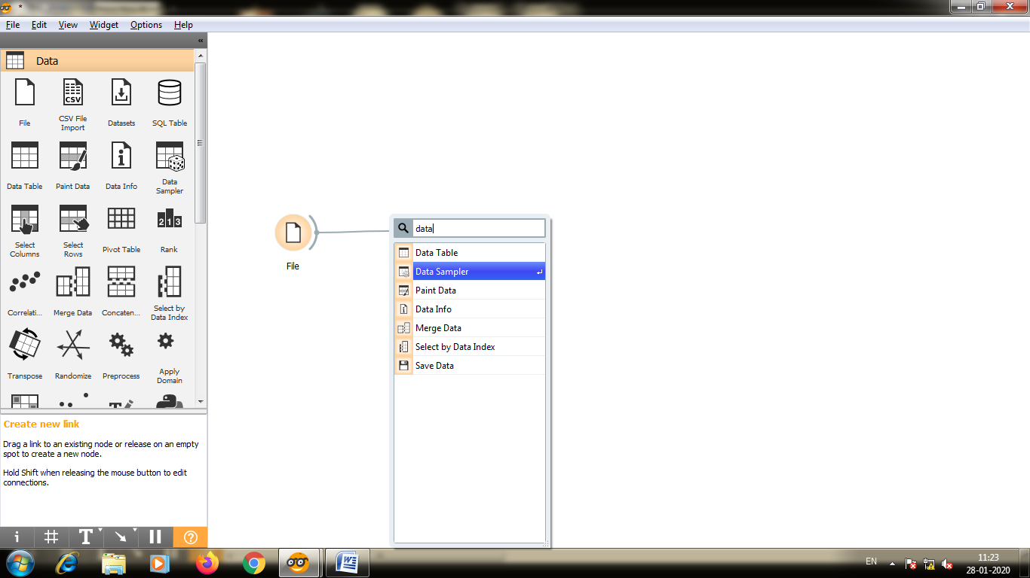

Step4:-Whenever we do prediction we will need to connect them with native bayes and classification tree to the prediction by dragging them across.

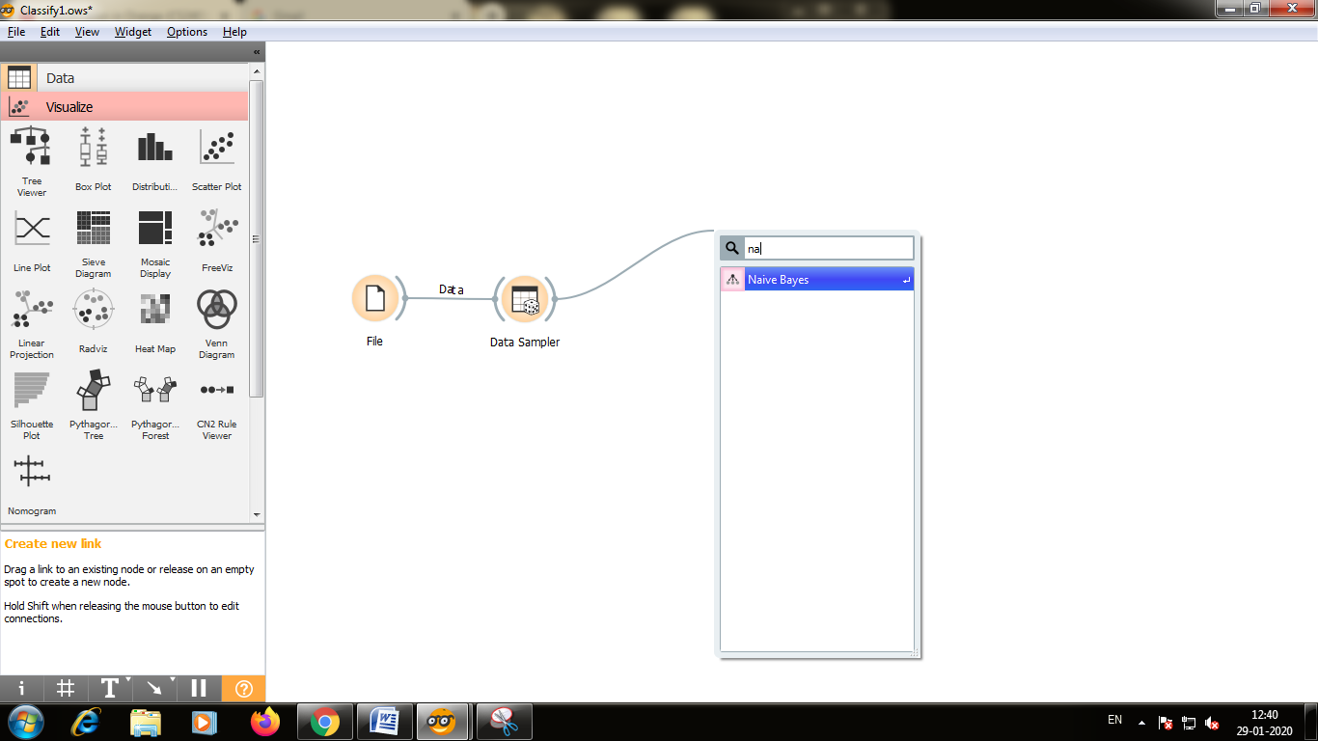

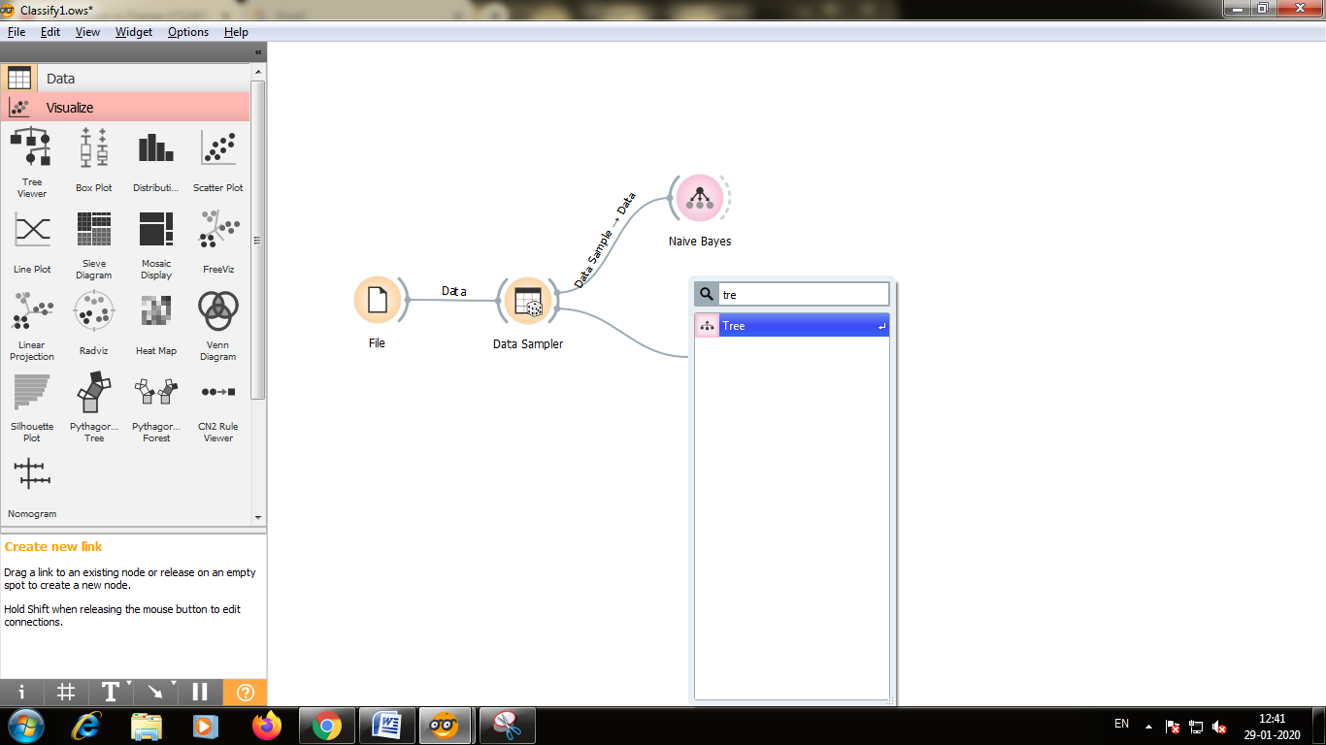

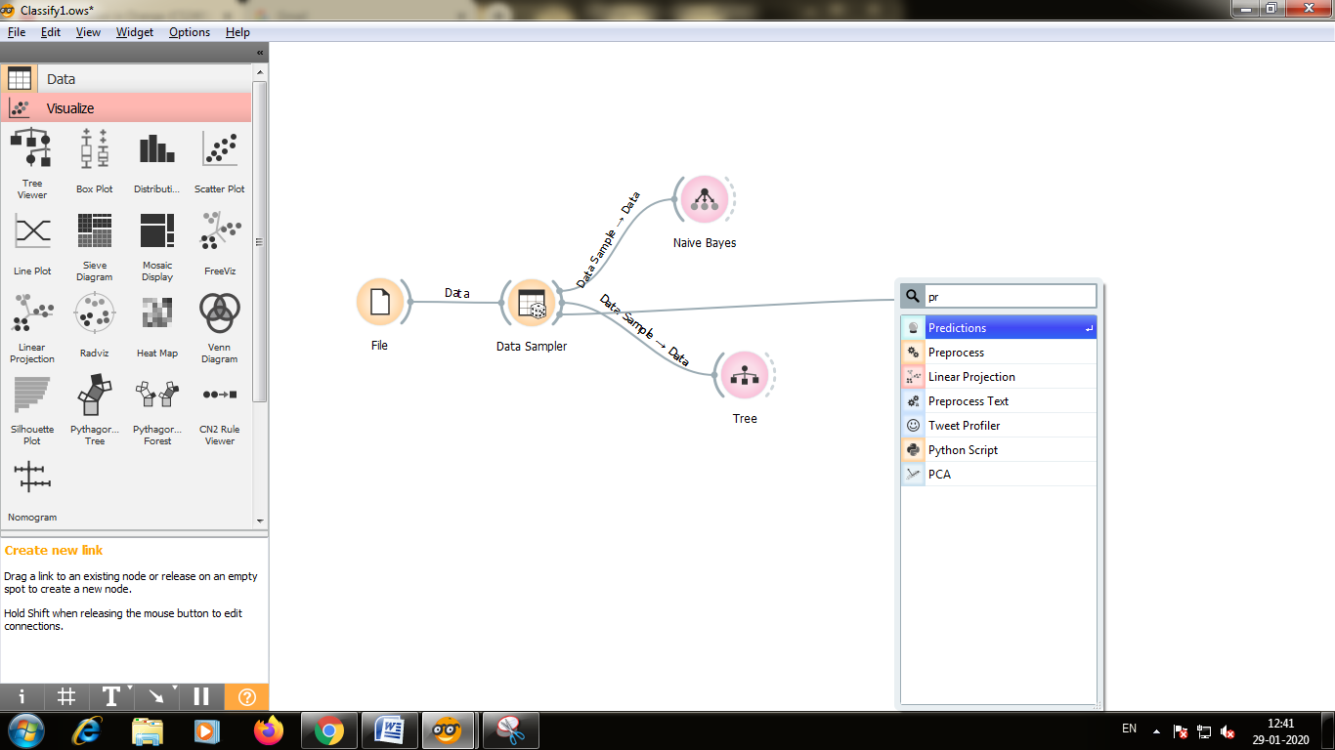

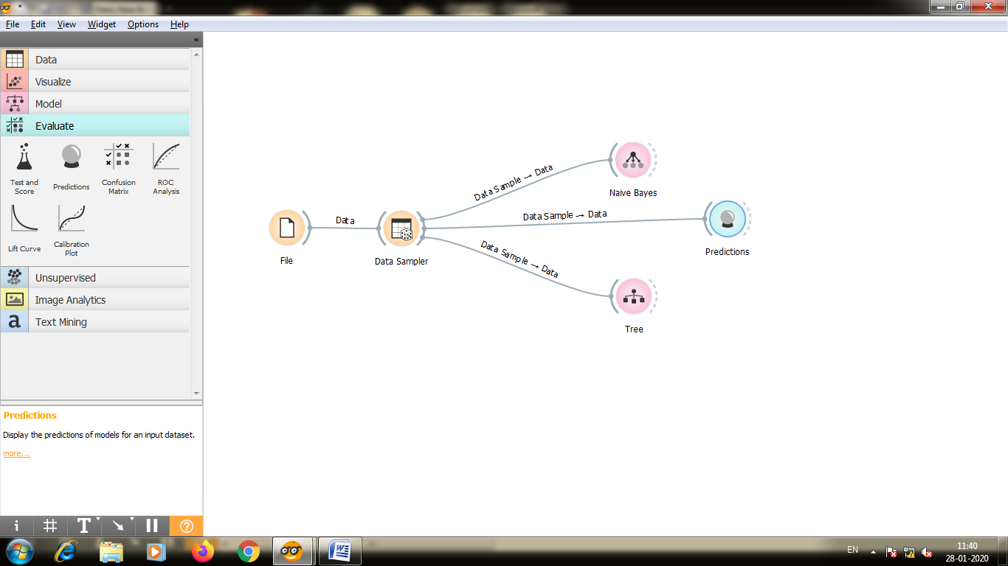

Step5:-The model is also able to show how you can predict the type class of the various attributes so you can use the nomogram for that double click on nomogram and you see the type of target class list so let’s see if the you want to see if the data input you can drag these points across by sliding across the data one means yes and zero means no

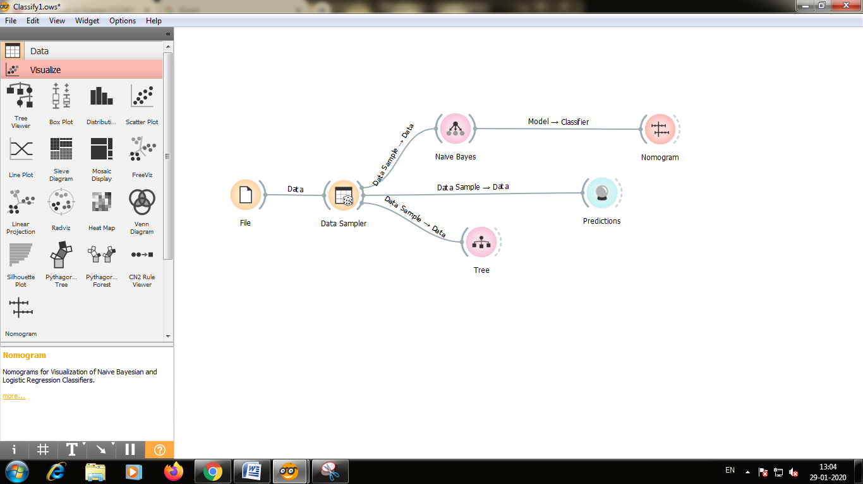

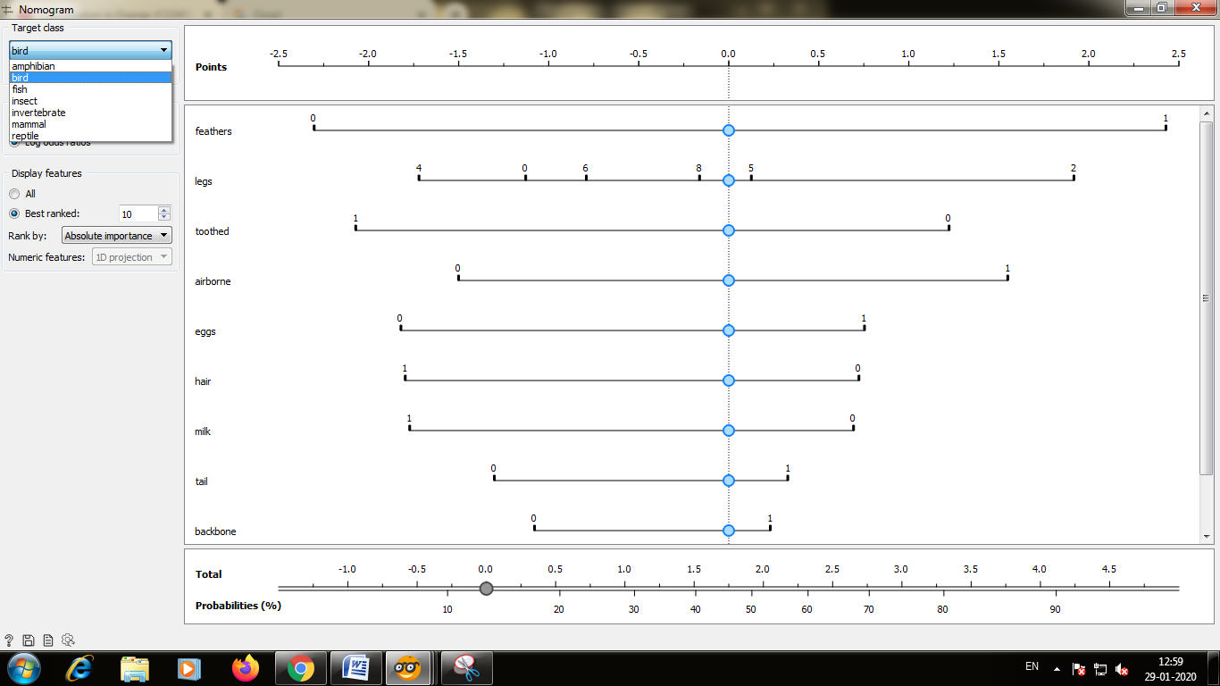

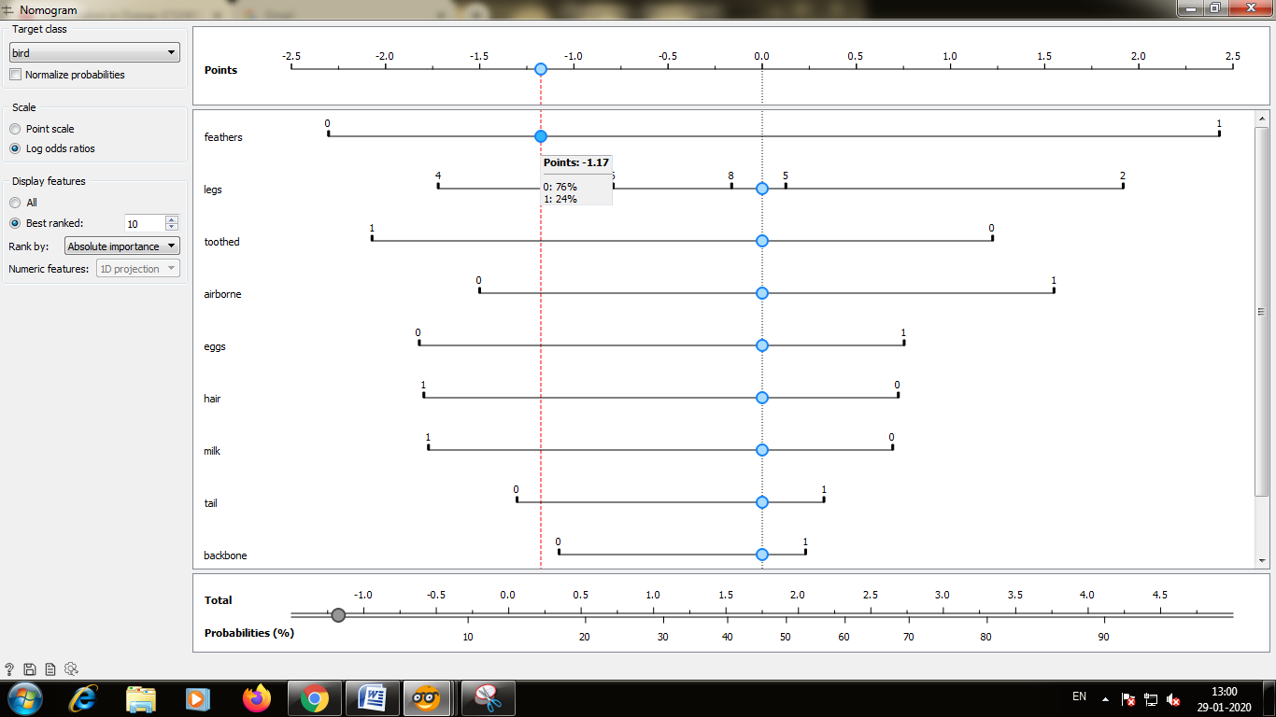

Step6:-Connect the Native Bayes and Classification Tree to Prediction

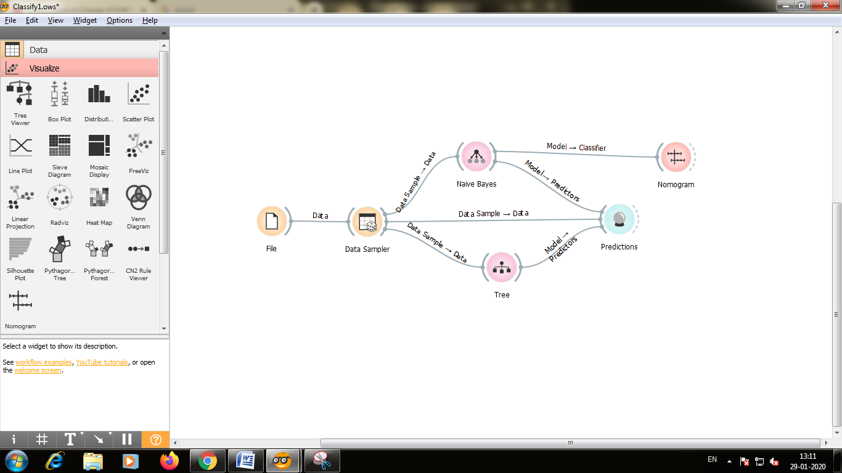

Step7:-Double click on the prediction and you will the data attributes by seeing this input from hair feathers eggs milk and so on.

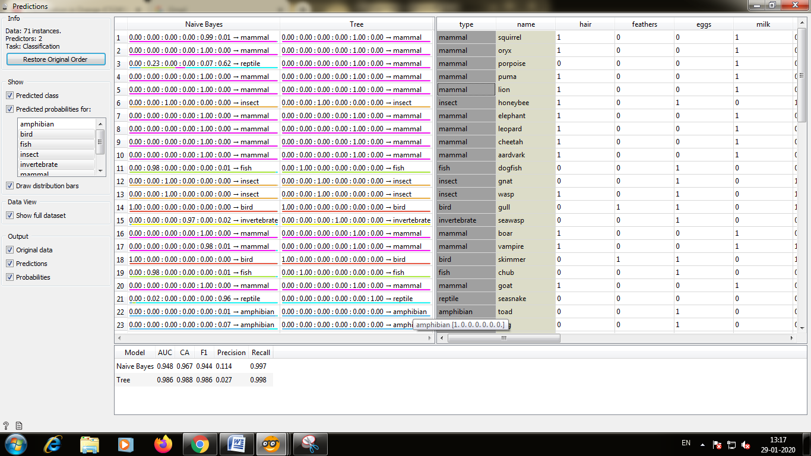

Step8:-There are different ways to visualize the data on the left side of the screen you can scroll down and you will see the visualize step so you click on the tab and you will see several regions that you can use to visualize the data like scatter plot,linear projection etc.

For this example we are going to use linear projection.

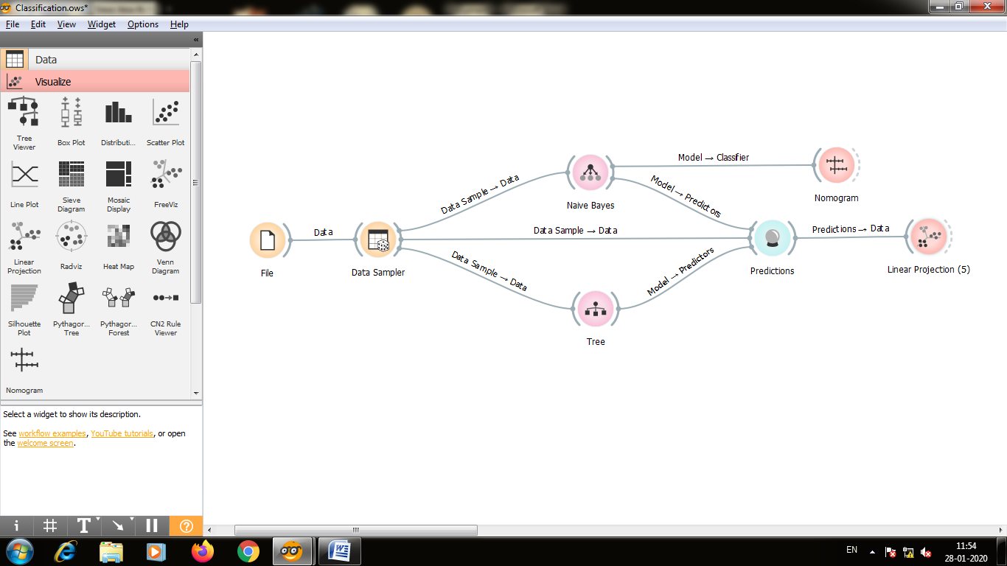Step9:-Double click on the linear projection and you can the different classes of zoo animal.

